# WEB TECHNOLOGIES LAB MANUAL

**Submitted to :** Pf. Kiran Jyoti

**Submitted by :** Tanuj Sharma

**C.R.N :** 1921106

**U.R.N :** 1905406

**PRACTICAL NO. 1**

Create a simple web pages by writing HTML using a simple text editor, notepad. Demonstrate the following components of the web page : page title and headings paragraph and inline images.

<html>

<html lang="en-us">

<head>

<title>WT Pract 1 </title>

</head>

<h1><center><strong><em>Guru Nanak Dev Engineering College.</em></strong></center></h1>

<body>

<img src="https://www.gndec.ac.in/sites/default/logo.png" alt="gne" width="1500" height="150">

<p style="color:rgba(13, 22, 134, 0.582);"><i>Guru Nanak Dev Engineering College</i>, one of the prestigious, oldest and minority institution of Northern India, was established under the aegis of Nankana Sahib Education Trust (NSET) in 1956. NSET was founded in memory of the most sacred temple of Nankana Sahib, birth place of Guru Nanak Dev Ji. Shiromani Gurudwara Prabandhak Committee, Amritsar, a premier organization of universal brotherhood, which is the main force behind the mission of "Removal of Economic Backwardness through Technology" and NSET with the same mission, established a Polytechnic in 1953 and Guru Nanak Dev Engineering College (GNDEC) in 1956. The Trust deed was registered on 24th February 1953 with a commitment by Nankana Sahib Education Trust to uplift the vast weaker section of Indian polity comprising Rural India by admitting 70% students every year from Rural Areas. This commitment was made to the nation on 8th April, 1956. The day when foundation stone of the College was laid by Late Dr. Rajendra Prasad Ji, the First President of India.</p><br>

</body>

</html>

**OUTPUT**

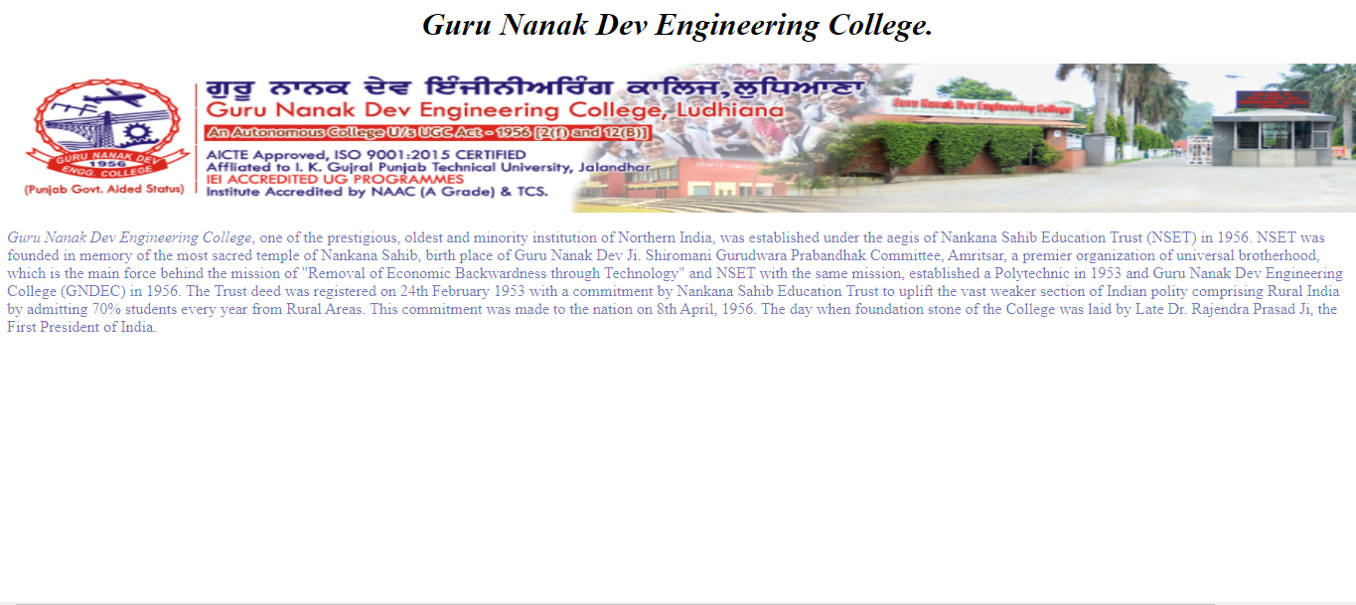

**PRACTICAL NO. 2**

Demonstrate the use of links, lints, and tables in html. You should be able to link separate pages and create named links within a document, using them to build a “table of contents”.

<!DOCTYPE html>

<html lang="en">

  <head>

    <meta charset="UTF-8" />

    <meta http-equiv="X-UA-Compatible" content="IE=edge" />

    <meta name="viewport" content="width=device-width, initial-scale=1.0" />

    <meta name="description" content="Ths Page is basically for Tables">

    <title>Practical 2</title>

    <style>

      table,

      th,

      td {

        border: 2px solid rgba(252, 223, 95, 0.918);

        border-collapse: separate;

        background-color: rgb(116, 200, 240);

      }

    </style>

  </head>

  <body style="text-align: center" >

    <h1> WT Practical 2 </h1>

    <h2>Use of Tables, Links and Lists </h2>

    <br />

    <table style="width: 60%; margin-left: auto; margin-right: auto">

      <tr>

        <th>Site Name</th>

        <th>Links</th>

        <th>Link Address</th>

      </tr>

      <tr>

        <td>GNDEC Student portal</td>

        <td><a href="https://guru.gndec.ac.in/" target="_blank">Guru Portal</a></td>

        <td>https://www.guru.gndec.ac.com/</td>

      </tr>

      <tr>

        <td>GNDEC</td>

        <td><a href="https://www.gndec.ac.in/" target="_blank">GNDEC</a></td>

        <td>https://www.gndec.ac.in/</td>

      </tr>

      <tr>

        <td>GNDEC Academics Portal</td>

        <td>

          <a href="https://academics.gndec.ac.in/" target="_blank">Academics Portal</a>

        </td>

        <td>https://www.academics.gndec.ac.com/</td>

      </tr>

    </table>

    <h3 style="text-align: left;">There are mainly 2 types of list: </h3>

    <ol style="text-align: left">

      <strong>Ordered List</strong>

      <li>GNDEC</li>

      <li>Ludhiana</li>

      <li>Punjab</li>

    </ol>

    <ul style="text-align: left">

      <strong>Unordered List</strong>

      <li>GNDEC</li>

      <li>Ludhiana</li>

      <li>Punjab</li>

    </ul>

  </body>

</html>

**OUTPUT**

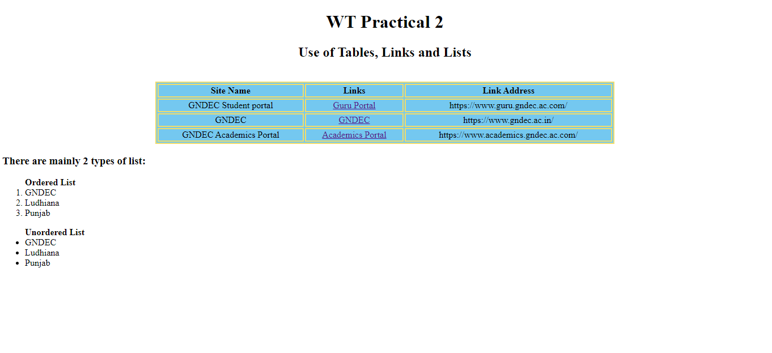

**PRACTICAL NO. 3**

Create a simple forms in HTML and demonstrate the use of various form elements like input box, textarea, submit and radio buttons etc.

<!DOCTYPE html>

<html lang="en">

<head>

    <meta charset="UTF-8">

    <meta http-equiv="X-UA-Compatible" content="IE=edge">

    <meta name="viewport" content="width=device-width, initial-scale=1.0">

    <title>WT practical 3</title>

</head>

<body style="background-color: rgba(232, 243, 128, 0.966);" >

    <h2><center>My first form</center></h2>

    <form action="2.html">

       Name: <input type="text" name="Name" >

       Roll No.: <input type="value" name="RollNo." >

       <br>

<br><div>Gender</div>

       <div>

         Male  <input type="radio" name="Gender" >

        Female  <input type="radio" name="Gender" >

        Others  <input type="radio" name="Gender" >

       </div>

       <br>

       Date of Birth <input type="date" name="DOB">

       <br><div><br>

       <div>

       Email Address : <input type="email" name="mailId" >

    </div>

<br>

<button type="submit"> Submit</button>

<button type="reset"> Reset</button>

</div>

    </form>

</body>

</html>

**OUTPUT**

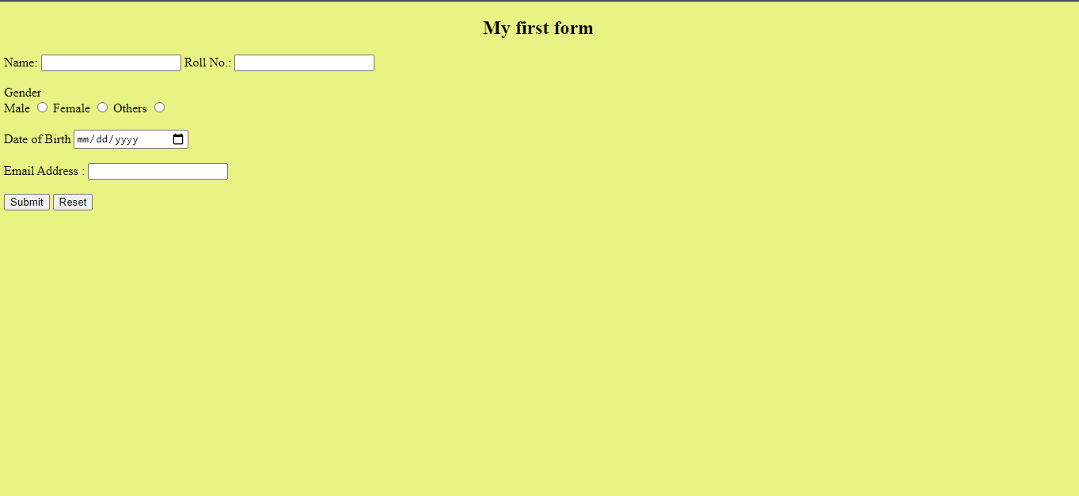

**PRACTICAL NO. 4**

Demonstrate the use of cascading style sheets(CSS) (inline, internal and external) to specify various aspects of style, such as colours and text fonts and sizes, in HTML document.

<!doctype html>

<html>

<head>

   <meta http-equiv="Content-Type" content="text/html; charset=utf-8" />

   <title>WT practical 4</title>

   <style>

      body{

      background-color:hsla(102, 81%, 70%, 0.904);

      }

      h1{

      color:rgb(233, 42, 169);

      text-align:center;

      text-transform:capitalize;

      text-decoration:underline;

      }

      p{

      font-size:15x;

      font-family:Verdana, Geneva, sans-serif;

      color:rgb(230, 129, 98);

      }

      h2{

      color:rgb(61, 9, 145);

      margin-left:10px;

      }

      img{

      border:10px           double rgb(7, 7, 7);

      width:400px;

      height:300px;

      margin-left:10px;

      }

      a{

      margin-left:10px;

      }

   </style>

</head>

<body>

   <h1>GLOBAL WARMING</h1>

   <p>Global warming is the long-term heating of Earth's climate system observed since the pre-industrial period (between 1850 and 1900) due to human activities, primarily fossil fuel burning, which increases heat-trapping greenhouse gas levels in Earth's atmosphere.</p>

   <h2>Image Affected with styles</h2>

   <img src="https://climate.nasa.gov/system/internal_resources/details/original/656_cc-vs-gw-vs-wx-470x246.jpg"><br /><br />

   <a href="https://climate.nasa.gov/resources/global-warming-vs-climate-change/" target="_blank">More</a>

</body>

</html>

**OUTPUT**

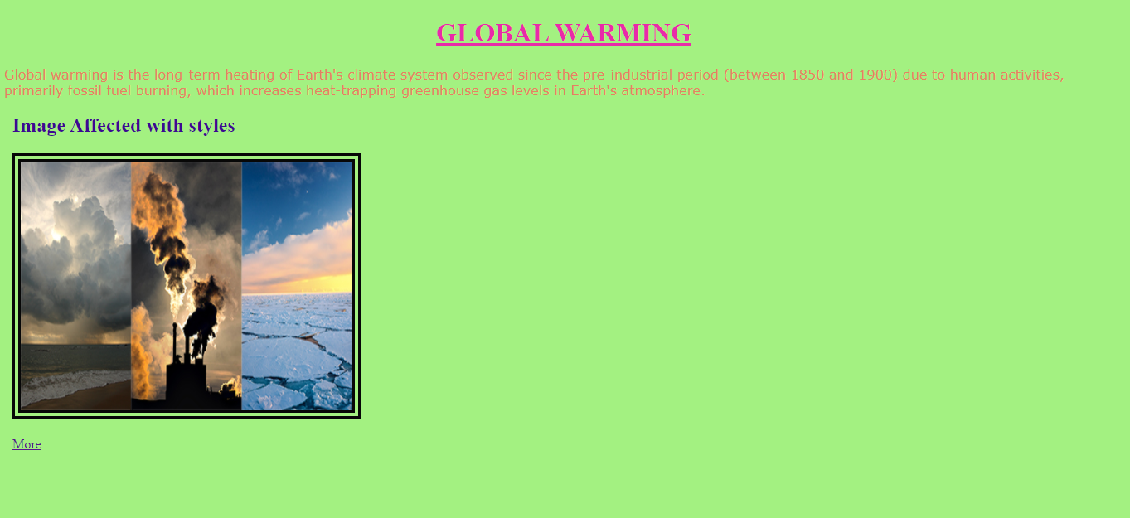

**PRACTICAL NO. 5**

Create of web pages using HTML5 & CSS3.

<!DOCTYPE html>

<html lang="en">

<head>

<title>CSS Template</title>

<meta charset="utf-8">

<meta name="viewport" content="width=device-width, initial-scale=1">

<style>

* {

box-sizing: border-box;

font-family: Arial, Helvetica, sans-serif;

}

body {

margin: 0;

font-family: Arial, Helvetica, sans-serif;

}

/* Style the top navigation bar */

.topnav {

overflow: hidden;

background-color: #333;

}

/* Style the topnav links */

.topnav a {

float: left;

display: block;

color: #f2f2f2;

text-align: center;

padding: 14px 16px;

text-decoration: none;

}

/* Change color on hover */

.topnav a:hover {

background-color: #ddd;

color: black;

}

/* Style the content */

.content {

background-color: #ddd;

padding: 10px;

height: 200px; /* Should be removed. Only for demonstration */

}

/* Style the footer */

.footer {

background-color: #f1f1f1;

padding: 10px;

}

</style>

</head>

<body>

<div class="topnav">

<a href="#">Link</a>

<a href="#">Link</a>

<a href="#">Link</a>

</div>

<div class="content">

<h2>Welcome to India</h2>

<p>Explore</p>

</div>

<div class="footer">

<p>Footer</p>

</div>

<canvas id="myCanvas" width="200" height="100" style="border:1px solid #d3d3d3;">

Your browser does not support the HTML canvas tag.</canvas>

<script>

var c = document.getElementById("myCanvas");

var ctx = c.getContext("2d");

// Create gradient

var grd = ctx.createLinearGradient(0,0,200,0);

grd.addColorStop(0,"red");

grd.addColorStop(1,"white");

// Fill with gradient

ctx.fillStyle = grd;

ctx.fillRect(10,10,150,80);

</script>

</body>

</html>

**OUTPUT**

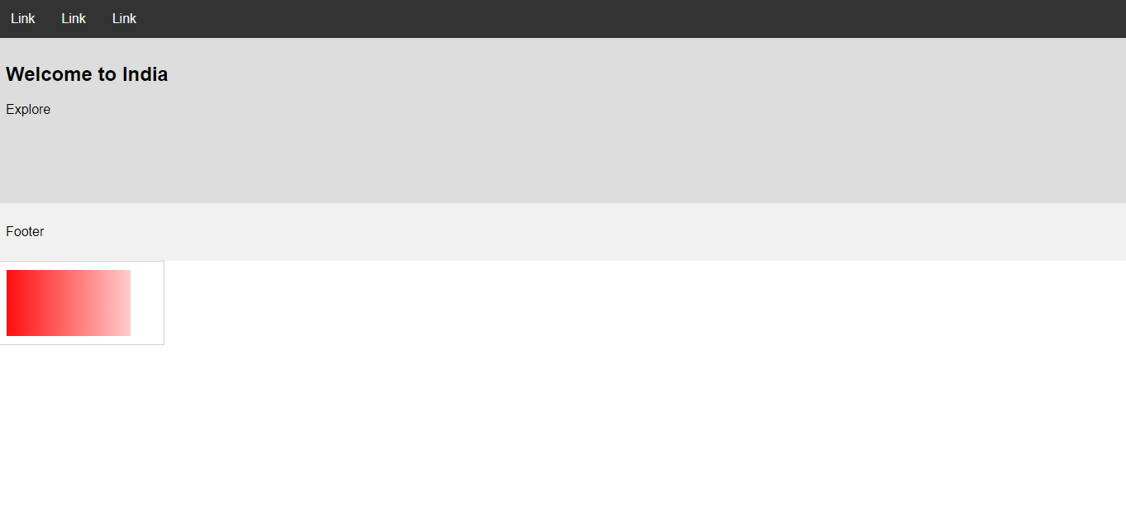

**PRACTICAL NO. 6**

Demonstrate the use of Bootstrap framework.

<!doctype html>

<html lang="en">

<head>

<meta charset="utf-8">

<meta name="viewport" content="width=device-width, initial-scale=1">

<link href="https://cdn.jsdelivr.net/npm/bootstrap@5.0.0-beta3/dist/css/bootstrap.min.css" rel="stylesheet"

integrity="sha384-eOJMYsd53ii+scO/bJGFsiCZc+5NDVN2yr8+0RDqr0Ql0h+rP48ckxlpbzKgwra6" crossorigin="anonymous">

<title>Quiz Coding</title>

</head>

<body>

<nav class="navbar navbar-expand-lg navbar-dark bg-primary">

<div class="container-fluid">

<a class="navbar-brand" href="#">Quiz Coding</a>

<button class="navbar-toggler" type="button" data-bs-toggle="collapse"

data-bs-target="#navbarSupportedContent" aria-controls="navbarSupportedContent" ariaexpanded="false"

aria-label="Toggle navigation">

<span class="navbar-toggler-icon"></span>

</button>

<div class="collapse navbar-collapse" id="navbarSupportedContent">

<ul class="navbar-nav me-auto mb-2 mb-lg-0">

<li class="nav-item">

<a class="nav-link " aria-current="page" href="#">Home</a>

</li>

<li class="nav-item">

<a class="nav-link " aria-current="page" href="#">Courses</a>

</li>

<li class="nav-item">

<a class="nav-link " aria-current="page" href="#">Future Tech</a>

</li>

<li class="nav-item">

<a class="nav-link" href="">About Us</a>

</li>

<li class="nav-item">

<a class="nav-link" href="">Contact Us</a>

</li>

</ul>

<form class="d-flex">

<input class="form-control me2" type="search" placeholder="Search" arialabel="Search">

<button class="btn btn-outline-success bg-danger" type="submit">Search</button>

</form>

</div>

</div>

</nav><br>

<div class="container">

<div id="carouselExampleCaptions" class="carousel slide carousel-fade" databsride="carousel">

<div class="carousel-indicators">

<button type="button" data-bs-target="#carouselExampleCaptions" data-bsslideto="0" class="active"

aria-current="true" aria-label="Slide 1"></button>

<button type="button" data-bs-target="#carouselExampleCaptions" data-bsslideto="1"

aria-label="Slide 2"></button>

<button type="button" data-bs-target="#carouselExampleCaptions" data-bsslideto="2"

aria-label="Slide 3"></button>

</div>

<div class="carousel-inner">

<div class="carousel-item active">

<img src="https://presentationdeck.com/wp-content/uploads/2015/11/computer-powerpoint-template.png" width="1150" height="650">

<div class="carousel-caption d-none d-md-block">

<div style="color: rgb(34,48,240);">

<h2>Welcome to Quiz Coding</h2>

<p>Learn to code from scratch </p>

</div>

<button class="btn btn-success ">Learn Code</button>

<button class="btn btn-success">Quiz</button>

<button class="btn btn-success">Prizes</button>

<button class="btn btn-success">Courses</button>

<button class="btn btn-success">Experts</button>

</div>

</div>

<div class="carousel-item">

<img src="https://encrypted-tbn0.gstatic.com/images?q=tbn:ANd9GcQEoOqGugVr-ENMDxgHyuWYHu6QIRQN_sTwiQ&usqp=CAU" width="1800" height="800">

<div class="carousel-caption d-none d-md-block">

<div style="color: rgb(34,48,240);">

<h2>Welcome to Quiz Coding</h2>

<p>Learn to code from scratch </p>

</div>

<button class="btn btn-success">Learn Code</button>

<button class="btn btn-success">Quiz</button>

<button class="btn btn-success">Prizes</button>

<button class="btn btn-success">Courses</button>

<button class="btn btn-success">Experts</button>

</div>

</div>

<div class="carousel-item">

<img src="images/p4.png.png" width="1600" height="400">

<div class="carousel-caption d-none d-md-block">

<div style="color: rgb(34, 48, 240);">

<h2>Welcome to Quiz Coding</h2>

<p>Learn to code from scratch </p>

</div>

<button class="btn btn-success ">Learn Code</button>

<button class="btn btn-success">Quiz</button>

<button class="btn btn-success">Prizes</button>

<button class="btn btn-success">Courses</button>

<button class="btn btn-success">Experts</button>

</div>

</div>

</div>

<button class="carousel-control-prev" type="button" databstarget="#carouselExampleCaptions"

data-bs-slide="prev">

<span class="carousel-control-prev-icon" aria-hidden="true"></span>

<span class="visually-hidden">Previous</span>

</button>

<button class="carousel-control-next" type="button" databstarget="#carouselExampleCaptions"

data-bs-slide="next">

<span class="carousel-control-next-icon" aria-hidden="true"></span>

<span class="visually-hidden">Next</span>

</button>

</div>

</div><br>

<div class="container marketing">

<div class="row">

<div class="col-lg-4">

<svg class="gne_front.jpg " width="140" height="140"

xmlns="http://www.w3.org/2000/svg" role="img" arialabel="Placeholder: 140x140"

preserveAspectRatio="xMidYMid slice" focusable="false">

<title>Placeholder</title>

<rect width="100%" height="100%" fill="#777" /><text x="50%" y="50%" f

ill="#777"

dy=".3em"></text>

</svg>

<h2>Courses</h2>

<p>Our Courses are provided accoring to age-group for better understanding and easy

to learn.</p>

<p><a class="btn btn-secondary" href="https://en.wikipedia.org/wiki/Technology">View details &raquo;</a>

</p>

</div>

<div class="col-lg-4" >

<svg class="bd-placeholder-img" width="140" height="140"

xmlns="http://www.w3.org/2000/svg" role="img" arialabel="Placeholder: 140x140"

preserveAspectRatio="xMidYMid slice" focusable="false">

<title >Placeholder</title>

<rect width="100%" height="100%" fill="#777" /><text x="50%" y="50%"

fill="#777"

dy=".3em"></text>

</svg>

<h2>Prizes</h2>

<p>We love to give prizes to quiz winners who had done any course from us and score

a good.</p>

<p><a class="btn btn-secondary"

href="https://www.sgs.com/en/campaigns/sgs-cybersecuritysolutionsldp?wt_mc_id=gDNICorp06004c&utm_source=Google&utm_medium=PPC_Search_Text_Ads&utm_campaig

n=Cyber_Security_Services_BA_Global_GSN_VR2&gclid=EAIaIQobChMI2Z7r6umj8AIVV0NgCh37JwrmEAAYAyAAEgIAqfD_BwE">View details &raquo;</a></p>

</div>

<div class="col-lg-4">

<svg class="https://encrypted-tbn0.gstatic.com/images?q=tbn:ANd9GcTzLRXmcex6jWwTUH9Xsoopz3O-EwcQjA-Zzg&usqp=CAU " width="140" height="140"

xmlns="http://www.w3.org/2000/svg" role="img" arialabel="Placeholder: 140x140"

preserveAspectRatio="xMidYMid slice" focusable="false">

<title>Placeholder</title>

<rect width="100%" height="100%" fill="#777" /><text x="50%" y="50%"

fill="#777"

dy=".3em">140x140</text>

</svg>

<h2>Quiz</h2>

<p>Lot of Quizes held every month be a part of it, sho your talent and win exciting Priz

essa </p>

<p><a class="btn btn-secondary"

href="https://www.investopedia.com/terms/a/artificialintelligenceai.asp#:~:text=Artifici

al%20intelligence%20(AI)%20refers%20to,as%20learning%20and%20prob

lem%2Dsolving.">View

details &raquo;</a></p>

</div>

</div>

</div>

<script src="https://cdn.jsdelivr.net/npm/bootstrap@5.0.0-beta3/dist/js/bootstrap.bundle.min.js"

integrity="sha384-JEW9xMcG8R+pH31jmWH6WWP0WintQrMb4s7ZOdauHnUtxwoG2vI5DkLtS3qm9Ekf"

crossorigin="anonymous"></script>

</body>

</html>

**OUTPUT**

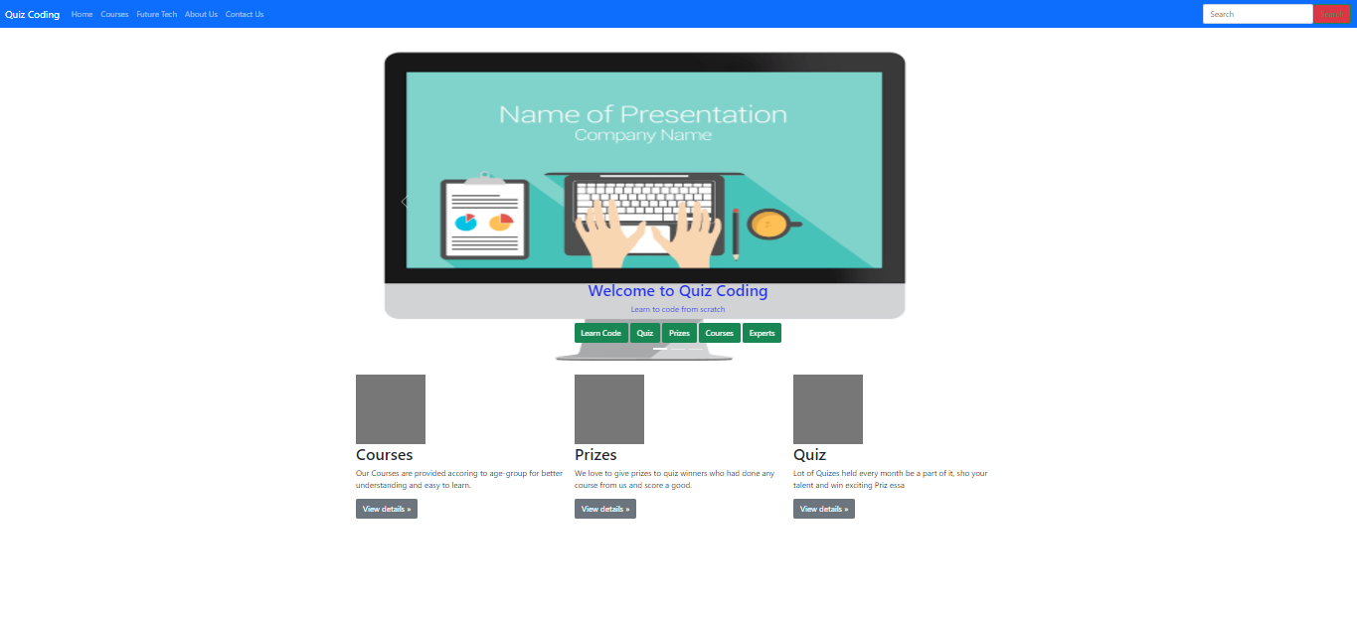

**PRACTICAL NO. 7**

Create a web page using PHP.

<!doctype html>

<html lang="en">

<head>

<meta charset="utf-8">

<meta name="viewport" content="width=device-width, initial-scale=1">

<link href="https://cdn.jsdelivr.net/npm/bootstrap@5.0.0-beta3/dist/css/bootstrap.min.css" rel="stylesheet"

integrity="sha384-eOJMYsd53ii+scO/bJGFsiCZc+5NDVN2yr8+0RDqr0Ql0h+rP48ckxlpbzKgwra6" crossorigin="anonymous">

<title>PHP|WEBPAGE</title>

<body>

<style>.topnav {

overflow: hidden;

background-color: #333;

}

.topnav a {

float: left;

color: #ffffff;

text-align: center;

padding: 14px 16px;

text-decoration: none;

font-size: 17px;

}

.topnav a:hover {

background-color: #86becc;

color: rgb(255, 255, 255);

}

.topnav a.active {

background-color: #86becc;

color: rgb(240, 240, 240);

}

</style>

</head>

<div class="topnav" style="border-radius: 2px;">

<a class="active" href="#HOME">HOME</a>

<a href="#Competition">Competition</a>

<a href="#Contact">Contact</a>

<a href="#About Us">About Us</a>

</div>

<br>

<div class="alert alert-warning alert-dismissible fade show" role="alert">

<strong>Accept Cookies</strong> Please accept cookies for better experience

<button type="button" class="btn-close" data-bs-dismiss="alert" arialabe

l="Close"></button>

</div><div class="container" >

<div id="carouselExampleSlidesOnly" class="carousel slide" data-bs-ride="carousel">

<div class="carousel-inner">

<div class="carousel-item active">

<img src="https://images.tynker.com/blog/wp-content/uploads/09-05-2017-why-coding-infographic-blog.png" width="1000" height="450">

<p style="color: rgb(19, 5, 58);">Our platform to help programmers make

it big in the world of algorithms, computer programming, and

programming contests. At our <br>

platform we work hard to revive the

geek in you by hosting a programming contest at the start of

the month and two smaller programming <br> challenges at the middle

and end of the month. We also aim to have training sessions

and discussions related to algorithms, binary search, <br>

technicalities like array size and the likes. Apart from

providing a platform for programming competitions,

We also has various algorithm <br> tutorials and

forum discussions to help those who are new to the

world of computer programming.</p>

</div>

</div>

</div>

</div>

</div><br>

<div class="card" style="width: 125rem; background: linear-gradient(rgb(107, 192, 231),rgb(220, 211, 235))" >

<div class="card-body" align="center">

<h5 class="card-title">Competition Course </h5>

<p class="cardtext">Click below to enroll and start your course </p>

<a href="#" class="btn btn-primary">Start your course</a>

</div>

</div>

</body>

</html>

**OUTPUT**

